|  |  |  |  |
| --- | --- | --- | --- |
| 1 | | 7,464.0 | |
| NUMERO DE FRONTERAS | | ENERGIA AGREGADA | |
|  | | | |
| NO | | 0 | |
| CONTRATO | | VENCIMIENTO CONTRATO | |

|  |
| --- |
| **NEW STETIC**  USUARIO |

|  |
| --- |
| Ejecutivo de cuenta |

|  |
| --- |
| PUNTO FOCAL |

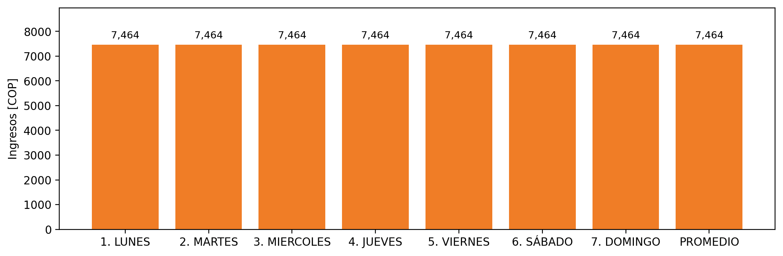

|  |  |  |  |  |  |  |  |  |  |  |
| --- | --- | --- | --- | --- | --- | --- | --- | --- | --- | --- |
| **FRONTERA** | **COD SIC** | **PREDIO** | **FRT DDV** | **TIPO DDV** | **PROMEDIO** | **PRÓXIMA ACTUALIZACIÓN** | **MARGEN DE ERROR** | **ÚLTIMA PRUEBA DDV** | **DÍAS PARTICIPACIÓN** | **FECHA REFERENCIA PRÓXIMA PRUEBA DDV** |
| PRODUCTORA Y COMERCIALIZADORA ODONTOLOGICA NEW STETIC S.A. | Frt03014 | Prd02382 | Frt43221 | LBC | 7,464 | 2022-01-19 | 4,99 | 2021-10-17 | 0.0 | 2022-02-27 |